Physical of system POS terminal

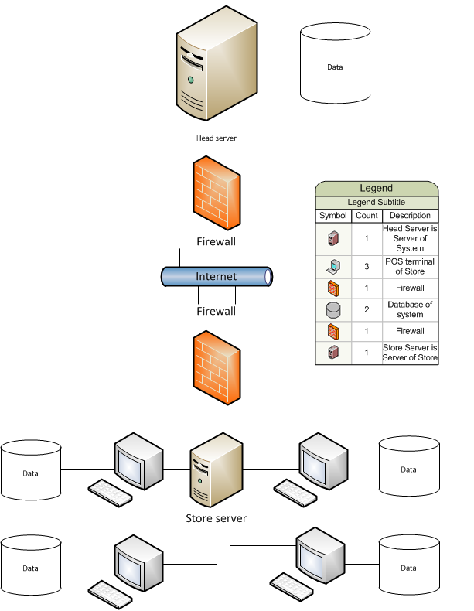

Sequence diagram cai nay huyen ve vo giay roi. Mai huyen dem len tai phan mem bi hu koh ve dc